Thomas Rafeld, M12808058

Ryan Winterhalter, M12727389

Lab 2 Report

**Objectives:**

In lab 2, the following objectives were explored: being able to design C++ classes, understanding why and how to use multiple files, understanding and being able to create constructors and destructors, and understanding inheritance, polymorphism, and encapsulation. The first outcome was the basis of the entire lab: creating a class that we then tested. This outcome is also essential to an engineering career as classes are used in many applications of programming as it can make a program easier to follow and use.  Classes are very important tools for organizing data and methods into objects that you can create and manipulate to execute your program’s desired tasks. As for the next learning objective, we used a header file and a main file to separate the class from the rest of the code. Separating class definitions in your header file makes it a lot easier to read through and follow your executable code, which makes troubleshooting and debugging a lot easier.  Additionally, separating class definitions into header files allows for you to reuse that code if you plan to use it in multiple different main functions. For a career this could be extremely helpful if the code needs to be shown to someone else (like working on code in groups) or if debugging is needed. We practiced another learning objective when we created constructors and a destructor for our class.  Constructors and destructors are an essential part of making a class. The constructors are needed to set up the class and then the destructors are needed at the end to clean up and ensure there are no memory leaks. This information is very important for a career in engineering and technology: the constructors are always needed to initialize any values needed and to ensure your object will be set up as expected, while destructors are needed so that memory leaks can be avoided, which is especially helpful if you are creating a program that will use a lot of memory throughout its operation (like is the case in the professional world). For the final outcome, we implemented three essential concepts of object-oriented programming: inheritance, encapsulation, and polymorphism. Inheritance was used when we created our derived class for task three so that it would be able to access its own functions as well as those of the base class from which it was derived. Encapsulation was used within our class because we combined both data and methods that manipulate that data into a singular object. Finally, polymorphism was used in task three to allow the menu to test functions from either the base or derived class in the header file, depending on which type of meeting the user would like to select. This final learning outcome is important to engineering because it incorporates three of the fundamental concepts of object-oriented programming.  These concepts allow for the creation of classes that derive from a base class so it can use the same methods without needing to create an entire new class with all those methods, a very important and highly applicable tool in programming.

**Task 2:**

**Task 3:**

**Video meeting tests:**

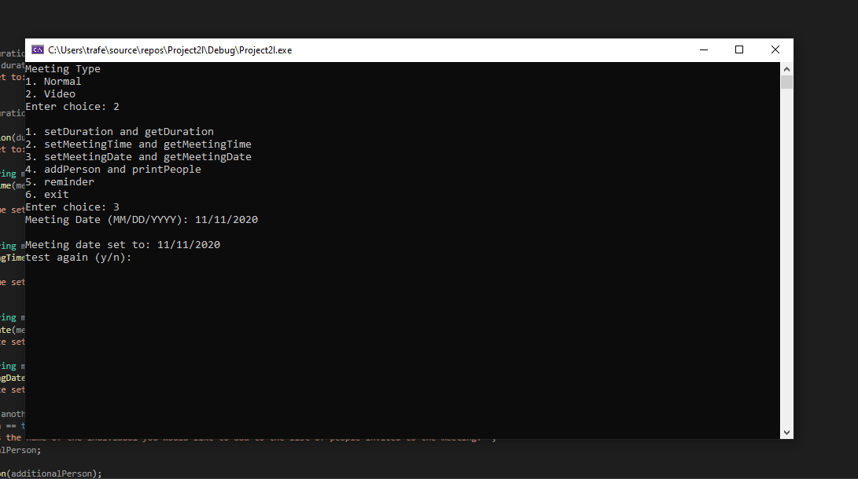

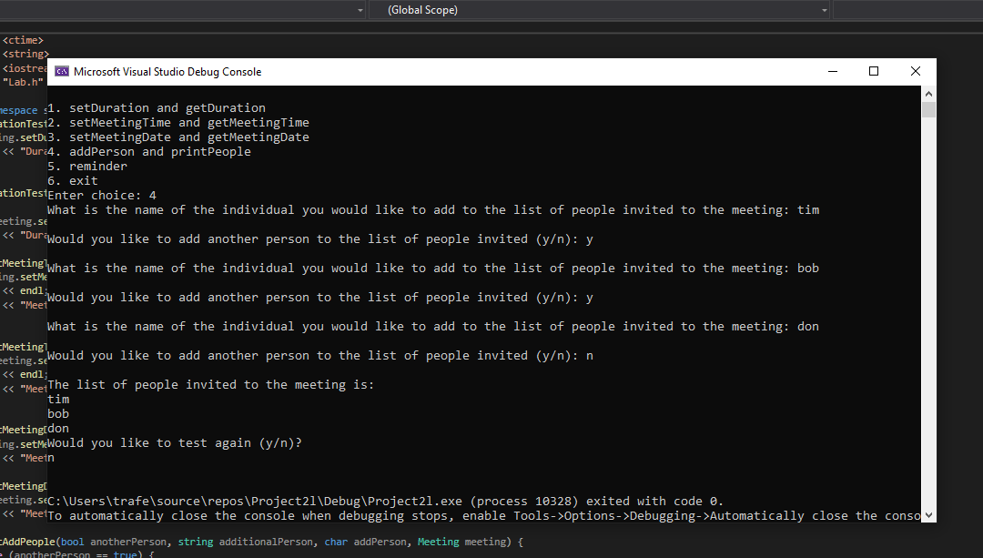

**Normal meeting tests:**

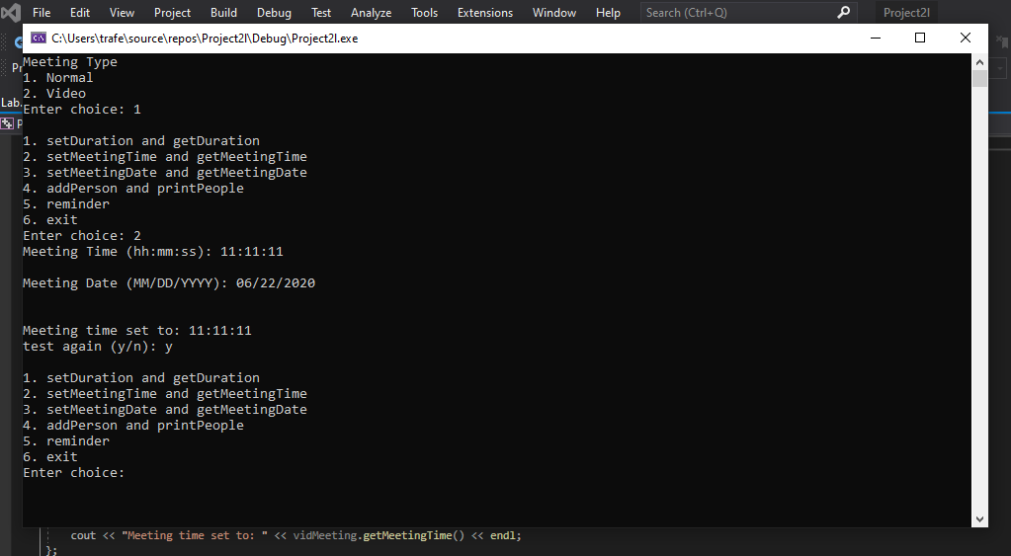

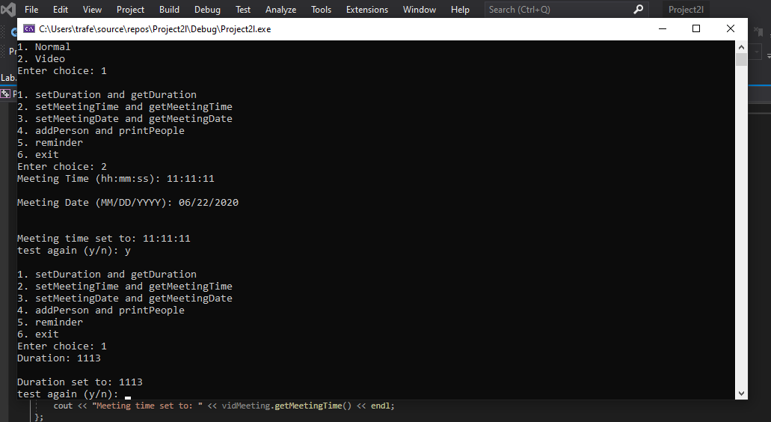

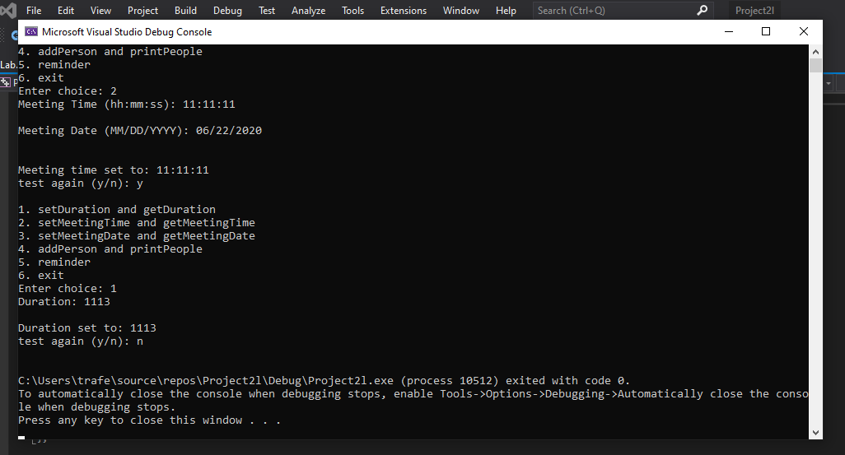

**Group Member Contribution:**

Lab was worked on together by both Ryan Winterhalter and Thomas Rafeld while on a call in  Microsoft Teams. Both worked on coding the class in the header file and making the menus in the main files for the different tasks. The destructor was figured out by Ryan, along with our function for adding people to the array, when we ran into problems with them.  The addition of video calling using separate functions was added by Thomas. For the final lab report, the first draft for the description of outcomes was written by Thomas and then edited by Ryan. The screenshots were taken and added by Thomas. Each member of our group should earn 100% percent of the grade as we feel that we both evenly contributed to the lab and worked on it together the whole time.